Memoria anual 2024-2025
Cátedra START-CEU-INTHEOS de Terapéutica Molecular del Cáncer

Resumen de memoria anual

I. Objetivos generales de la cátedra descritos en memoria de constitución
- Investigación: impulsar proyectos de investigación en el campo de los nuevos tratamientos del cáncer, así como las bases moleculares implicadas en su génesis o en la sensibilidad o resistencia a estos nuevos tratamientos.
Los objetivos científicos específicos serán los siguientes:
  - Identificar vulnerabilidades terapéuticas en cáncer
  - Identificar mecanismos de resistencia a tratamientos dirigidos
  - Estudiar combinaciones terapéuticas en cáncer
  - Diseñar herramientas terapéuticas incluyendo compuestos biológicos y/o compuestos químicos
- Docencia: se incluirá como parte de la actividad de esta cátedra el Máster en Medicina de la Facultad de Medicina.
- Gestión del conocimiento: organización de jornadas científicas, cursos, simposios o reuniones de expertos, así como la publicación de documentos o monografías relativas a nuevos tratamientos del cáncer, así como las bases moleculares implicadas en su génesis o en la sensibilidad o resistencia a estos nuevos tratamientos.

Investigadores START: Dr Victor Moreno, Dra María De Miguel, Dr Manuel Pedregal, Dra Irene Moreno, Dr Jorge Ramón, Dr Bernard Doger, Dra Ester García.
Profesores investigadores CEU: Dra Verónica Alonso, Dr Luis Álvarez, Dra Elena Izquierdo, Dra Silvia Martin Lluesma, Dr Osvaldo Graña

Resumen 2024-2025

Proyectos Específicos de la cátedra INTHEOS-START-CEU
  - Fusión FGFR3-TACC3 en cáncer de vejiga
Datos informáticos generados y actualmente desarrollando experimentos de laboratorio
  - Metilación del promotor de MTAP en hepatocarcinoma
Datos informáticos generados y actualmente desarrollando experimentos de laboratorio. Articulo en escritura.
  - Identificación de proteínas del surfaceoma en tumores gástricos y de esófago Datos informáticos extraídos

Gestión del conocimiento
Se está planificando el desarrollo de una jornada científica sobre investigación traslacional para el Otoño de 2025

- In silico evaluation of the immunogenic profile of lung cancers with SMARCA4 genetic alterations. Nieto-Jiménez C, Garcia-Lorenzo E, Diaz- Tejeiro C, Paniagua-Herranz L, Sanvicente A, Doger B, Moreno I, Pedregal M, Bartolomé J, Manzano A, Munkácsy G, Győrffy B, Pérez-Segura P, Calvo E, Moreno V, Ocana A.Sci Rep. 2025 May 22;15(1):17832. doi: 10.1038/s41598- 025-02494-x.PMID: 40404793

- Clinical and Immunologic Characteristics of Colorectal Cancer Tumors Expressing LY6G6D. Sanvicente García A, Pedregal M, Paniagua-Herranz L, Díaz-Tejeiro C, Nieto-Jiménez C, Pérez Segura P, Munkácsy G, Győrffy B, Calvo E, Moreno V, Ocaña A.Int J Mol Sci. 2024 May 14;25(10):5345. doi: 10.3390/ijms25105345.PMID: 38791382

- In Silico Transcriptomic Expression of MSR1 in Solid Tumors Is Associated with Responses to Anti-PD1 and Anti-CTLA4 Therapies. Sanvicente A, Díaz-Tejeiro C, Nieto-Jiménez C, Paniagua-Herranz L, López Cade I, Balázs G, Moreno V, Pérez-Segura P, Calvo E, Ocaña A.Int J Mol Sci. 2024 Apr 3;25(7):3987. doi: 10.3390/ijms25073987.PMID: 38612803

- Genomic and Immunologic Correlates in Prostate Cancer with High Expression of KLK2. Paniagua-Herranz L, Moreno I, Nieto-Jiménez C, Garcia- Lorenzo E, Díaz-Tejeiro C, Sanvicente A, Doger B, Pedregal M, Ramón J, Bartolomé J, Manzano A, Gyorffy B, Gutierrez-Uzquiza Á, Pérez Segura P, Calvo E, Moreno V, Ocana A.Int J Mol Sci. 2024 Feb 13;25(4):2222. doi: 10.3390/ijms25042222.PMID: 38396898

Publicaciones con referencia a cátedra CEU-INTHEOS-START

Integrating artificial Intelligence in drug discovery and early clinical development: a transformative approach
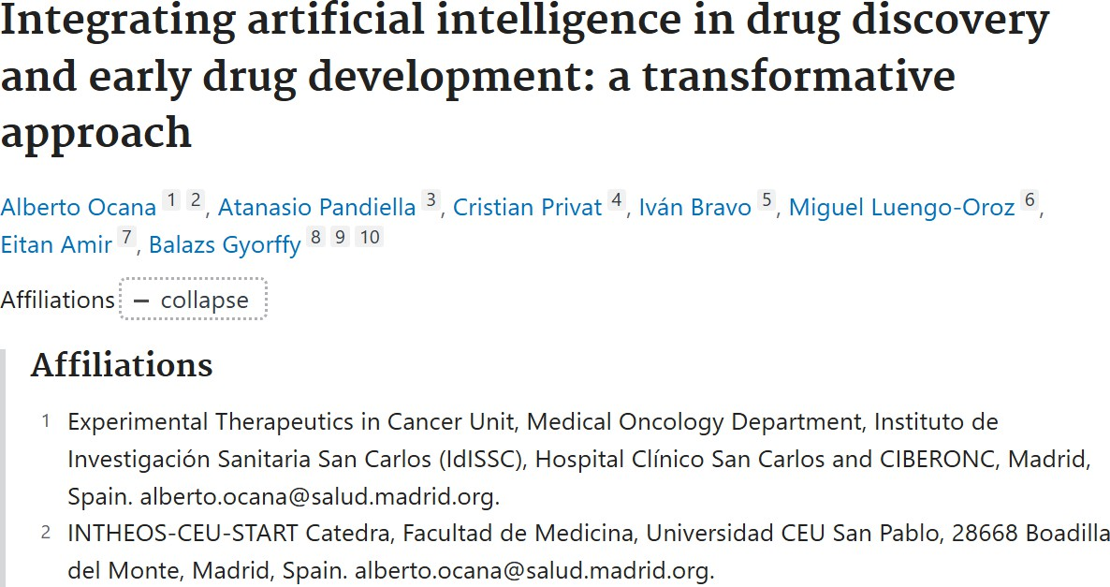

Revista Biomarker Research. Factor de Impact 9.5

- Tumor-Type Specific Methylation Patterns of MTAP and in vitro response to PRMT5 inhibition. En preparación y escritura

Resumen de resultados proyectos de laboratorio de la Catedra

Se han iniciado tres líneas de investigación dentro del proyecto de búsqueda de pacientes con fenotipos extremos y biomarcadores de respuesta:

- Análisis transcriptómica y mutacional de tumores con fusión de FGFR3-TCC3 para la evaluación de nuevas vulnerabilidades terapéuticas
- Análisis del patrón de metilación de MTAP en tumores sólidos y evaluación de actividad antitumoral de inhibidores de PBMRT5
- Identificación de proteínas del surfaceoma en tumores gástricos y de esófago

Durante este año se ha realizado un análisis computacional para evaluar estas alteraciones genómicas. Este servicio se ha realizado externamente a través de un proveedor externo especializado.
Actualmente estos datos están usándose para planificar los experimentos de laboratorio que se realizarán dentro del laboratorio CEU San Pablo en el marco de la cátedra INTHEOS-CEU-START
Durante el año 2025 se están generando datos de laboratorio con diferentes modelos celulares.

Datos preliminares del proyecto: Hipermetilación de promotor de MTAP como mecanismo de sensibilidad a inhibidres de PRMT 5

Artículo en preparación
Tumor-Type Specific Methylation Patterns of MTAP and in vitro response to PRMT5 inhibition

Luis Álvarez, Dalma Muller, Lucia Paniagua, Verónica Alonso, Manuel Pedregal, Esther Cabañas Morafraile, Bernard Doger, Emiliano Calvo, María Escribese, Balazs Gyorffy, Victor Moreno and Alberto Ocana

Abstracts
MTAP deficiency represents a therapeutically actionable vulnerability in multiple cancers, largely through its synthetic lethal interaction with PRMT5 inhibition. Current clinical strategies primarily rely on genomic deletion of MTAP as the sole biomarker for patient selection. Here, we report that MTAP expression is also regulated through promoter-proximal hypermethylation independent of genomic loss. By integrating DNA methylation and gene expression data across The Cancer Genome Atlas and cancer cell lines from the ENCODE project, we identify specific CpG sites whose hypermethylation strongly correlates with MTAP transcriptional repression. In human samples XXX . This data was confirmed in human cancer cell lines XXX. Finally, in vitro evaluation of PMRT5 activity demonstrated that XXX. Our findings reveal an epigenetically defined subset of MTAP-low tumors that may expand the population of patients eligible for PRMT1-targeted therapies, underscoring the importance of incorporating epigenomic biomarkers into precision oncology frameworks.

Introduction
The MTAP (methylthioadenosine phosphorylase) gene encodes a key enzyme in the methionine salvage pathway, responsible for the catabolism of methylthioadenosine (MTA) to adenine and 5-methylthioribose-1-phosphate (REF). This pathway serves to recycle methionine and maintain intracellular pools of S-adenosylmethionine (SAM), a central methyl donor for numerous methylation reactions essential to DNA, RNA, protein, and lipid metabolism (REF). Loss of MTAP function disrupts this balance, promoting metabolic vulnerability that has attracted considerable interest as a targetable feature in cancer (REF).
Homozygous deletion of MTAP is one of the most frequent genomic alterations observed across a diverse spectrum of human malignancies (REF). This recurrent loss often occurs as a collateral consequence of co-deletion with the adjacent tumor suppressor locus CDKN2A on chromosome 9p21 (REF). The absence of MTAP results in the intracellular accumulation of MTA, which acts as a competitive inhibitor of protein arginine methyltransferases (PRMTs), including PRMT5 and PRMT1 (REF). This inhibitory effect sensitizes MTAP-deficient tumors to PRMT inhibition, mainly PRMT5, establishing synthetic lethal interactions that have become the basis for the development of inhibitors in this subgroup of patients (REF).

The emergence of PRMT inhibitors in early-phase clinical trials has placed MTAP status at the forefront of biomarker-driven patient selection (REF). Current trial designs almost exclusively rely on detection of MTAP homozygous deletion through genomic profiling as a surrogate for functional loss of MTAP activity (REF). While this approach successfully identifies patients with copy number loss, it does not account for tumors where MTAP expression is suppressed via alternative, non-genetic mechanisms. Indeed, growing evidence suggests that epigenetic silencing through promoter hypermethylation may independently reduce MTAP expression without affecting genomic integrity (REF). Such epigenetically silent tumors remain invisible to conventional DNA-based assays, potentially excluding a substantial subset of patients who could benefit from PRMT-targeted therapies (REF).
DNA methylation at CpG-rich promoter regions is a well-established mechanism for transcriptional repression in cancer, frequently contributing to tumor suppressor gene inactivation (REF). However, the contribution of MTAP promoter methylation to its regulation remains incompletely defined across tumor lineages, and systematic pan-cancer analyses integrating DNA methylation and gene expression data remain limited (REF). The possibility that promoter hypermethylation may functionally mimic MTAP deletion has significant implications for biomarker development, patient stratification, and therapeutic targeting.
In this study, we performed an integrative analysis of MTAP methylation and gene expression profiles across multiple cancer types using comprehensive datasets from The Cancer Genome Atlas (TCGA) and a panel of human cancer cell lines from the ENCODE project. By interrogating CpG loci targeting MTAP captured by the Illumina HumanMethylation450K array platform, we systematically characterized promoter and gene body methylation patterns in relation to MTAP transcriptional activity.
Our findings reveal that promoter-proximal hypermethylation strongly correlates with MTAP silencing in specific tumor types, independent of genomic deletion. These results define an epigenetically distinct subset of MTAP-low tumors that may broaden the population of patients eligible for PRMT5-targeted therapy, underscoring the importance of integrating epigenomic biomarkers into precision oncology frameworks.

Methods
Data Collection and Processing
Comprehensive gene expression and DNA methylation datasets were obtained from The Cancer Genome Atlas (TCGA) through the Genomic Data Commons (GDC) portal. Data retrieval was performed using the TCGAbiolinks R package (version X.X.X), which facilitates efficient access, pre-processing, and integration of multiple TCGA data types. Only studies that provided both high-throughput RNA sequencing (RNA-seq) data and Illumina HumanMethylation450K (HM450K) array data for the same patient samples were included in this analysis to enable integrated transcriptomic and epigenomic profiling.
Raw RNA-seq read counts were processed and normalized using the DESeq2 R package (version X.X.X). This method employs a negative binomial distribution to account for variance in count data and provides variance-stabilized expression values suitable for downstream correlation analyses. Ensembl gene identifiers were mapped to HGNC gene symbols using the ensembldb package (version X.X.X), which ensures consistent and up-to-date gene annotation across all datasets.

Methylation data were processed starting from raw signal intensities obtained from HM450K arrays. Quality control filtering was applied based on detection p-values, excluding probes with p-values exceeding 0.01 in any given sample to ensure reliable signal detection. Probes that were known to overlap with common single nucleotide polymorphisms (SNPs) or that displayed potential cross-hybridization artifacts were systematically excluded, based on publicly available annotation files and previous validation studies. CpG sites were annotated according to the manufacturer’s manifest file (Illumina HumanMethylation450K v1.2).
Beta values, representing the proportion of methylation at individual CpG loci, were calculated using the standard formula:
β=MM+U+100\beta = \frac{M}{M + U + 100}β=M+U+100M
where M denotes methylated signal intensity and U denotes unmethylated signal intensity. To address type II probe design bias inherent in HM450K data, beta-mixture quantile normalization (BMIQ) was applied using the wateRmelon R package (version X.X.X). This normalization procedure adjusts for the systematic technical differences between type I and type II probes, improving the comparability of methylation measurements across the full spectrum of CpG sites.
External Methylation Data in Cell Lines
To complement the patient-derived data, we incorporated DNA methylation profiles from established human cell lines. Specifically, HM450K array data from 63 cancer cell lines were obtained from the ENCODE project (GEO accession: GSE40699). These data were processed following the same quality control and normalization pipeline described above, allowing for direct comparison between cell lines and patient tumor samples.
Statistical Analysis
To explore the relationship between gene expression and DNA methylation at the MTAP locus, Pearson correlation coefficients (r) and associated p-values were calculated. Correlation analyses were performed between log2-transformed RNA-seq read counts of the MTAP gene and the beta values of each corresponding CpG site across matched samples. All statistical analyses were conducted using R (version X.X.X), and multiple testing correction was applied where appropriate using the Benjamini-Hochberg method.
Data Visualization
The methylation status of four CpG sites located within or proximal to the MTAP gene was visualized using boxplots, scatterplots, and heatmaps generated with the ggplot2 (version X.X.X) and ComplexHeatmap (version X.X.X) R packages. These visualizations were used to evaluate methylation patterns across different samples and to illustrate the observed correlations with MTAP gene expression levels.

Results
Integrated Analysis of MTAP Methylation and Gene Expression Across Multiple Cancer Types
A comprehensive cohort comprising 6,187 samples with matched DNA methylation and gene expression data was assembled from 17 distinct TCGA projects (Figure 1A). The analyzed samples represented a broad spectrum of tissue origins, encompassing normal controls, primary

tumors, and metastatic lesions, thereby providing a wide biological and clinical context for assessing methylation-dependent regulation of MTAP expression (Table 1).
Genomic Distribution of MTAP-Associated CpG Probes
The Illumina HumanMethylation450K array contains four probes targeting CpG sites associated with the MTAP locus. Two of these probes, cg25162921 and cg00230302, map to promoter- proximal regions, specifically within 1500 bp (TSS1500) and 200 bp (TSS200) upstream of the transcription start site (TSS), respectively. The remaining two probes, cg13492671 and cg14548963, are positioned within the gene body (Figure 1B). The distinct genomic localization of these probes enables evaluation of both promoter methylation, which is typically associated with transcriptional repression, and gene body methylation, which may reflect more complex regulatory dynamics.
Correlation Between DNA Methylation and MTAP Gene Expression
To investigate the potential regulatory impact of DNA methylation on MTAP transcription, Pearson correlation analyses were performed between beta values of each CpG site and log2- transformed MTAP gene expression levels across all cancer types. Notably, two CpG probes demonstrated robust and statistically significant correlations, defined by absolute correlation coefficients exceeding 0.4.
The promoter-proximal probe cg25162921 exhibited a strong inverse correlation with MTAP
expression in multiple tumor types, including lung squamous cell carcinoma (TCGA-LUSC; r =
-0.48), bladder urothelial carcinoma (TCGA-BLCA; r = -0.42), and glioblastoma multiforme (TCGA-GBM; r = -0.45) (Figure 2 and table 2). These findings suggest that hypermethylation of the proximal promoter region may contribute to transcriptional silencing of MTAP in these tumor contexts.
Conversely, gene body methylation at cg13492671 displayed a significant positive correlation with MTAP expression in glioblastoma multiforme (TCGA-GBM; r = 0.43) and skin cutaneous melanoma (TCGA-SKCM; r = 0.46) (Figure 2, Table 2). These observations are consistent with emerging evidence that gene body methylation may, in certain contexts, be associated with active transcription or alternative regulatory mechanisms distinct from promoter methylation (REF).
Collectively, these results highlight tumor type–specific patterns of MTAP methylation and suggest differential roles for promoter- and gene body–localized CpG methylation in modulating MTAP gene expression across diverse cancer types.

Methylation Landscape of MTAP-Associated CpG Sites in Cancer Cell Lines
We next investigated the DNA methylation status of the four MTAP-associated CpG probes in a panel of 63 human cancer cell lines using HM450K array data obtained from the ENCODE project. As expected, the methylation distribution patterns revealed distinct behaviors for each CpG site (Figure 3A, B Table 3).

The CpG probes cg14548963 and cg13492671, both located within the gene body of MTAP, exhibited frequent hypermethylation across the analyzed cell lines, with 57 and 54 cell lines respectively displaying beta values exceeding 0.6 (β > 0.6), indicating a high level of methylation at these loci (Figure 3B). In contrast, cg00230302, located within the TSS200 promoter-proximal region, did not show evidence of hypermethylation in any of the examined

cell lines, suggesting that this region remains largely unmethylated across diverse tumor types in vitro (Figure 3B). Interestingly, the promoter-associated CpG site cg25162921, positioned approximately 1500 bp upstream of the transcription start site (TSS1500) demonstrated intermediate behavior, with 17 out of 63 cell lines (approximately one-third) exhibiting hypermethylation (β > 0.6) (Figure 3B).

Given the regulatory relevance of promoter methylation in gene silencing, we focused particularly on cg25162921. In our prior analysis of patient-derived samples from the Genomic Data Commons (GDC), hypermethylation at cg25162921 was significantly and negatively correlated with MTAP gene expression across multiple tumor types (Figure 2). This suggests that promoter hypermethylation at this specific locus may contribute to transcriptional repression of MTAP.

To further characterize the potential transcriptional impact of cg25162921 hypermethylation in vitro, we separately visualized its methylation profile in cell lines exhibiting high methylation levels (β > 0.6) (Figure 3). A detailed annotation of the individual cell lines and their corresponding methylation states (Figure 4??) is provided in table 3 facilitating direct comparison between methylation status and biological or histological features of the respective models.

These results collectively suggest that gene body methylation at MTAP is prevalent across diverse cancer cell types, while promoter-proximal methylation at cg25162921 occurs in a subset of cell lines and may represent a functionally relevant epigenetic mechanism regulating MTAP expression.

Differential MTAP Inactivation Modulates Sensitivity to PRMT5 Inhibition At this moment we are generating in vitro data for this particular part.
Given the therapeutic relevance of MTAP loss for PRMT-targeted strategies, we next sought to investigate whether the mechanism of MTAP inactivation — genomic deletion versus promoter hypermethylation — influences cellular sensitivity to PRMT5 inhibition. A panel of cell lines including …..

To address this, we integrated available pharmacogenomic data from cancer cell line panels treated with PRMT5 inhibitors, stratified by MTAP genomic status and methylation levels at the promoter-proximal CpG site cg25162921.

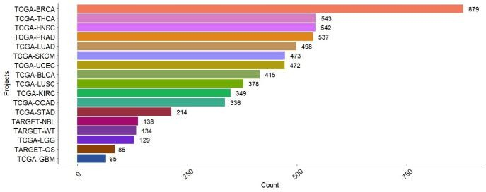
Fi ure 1 A

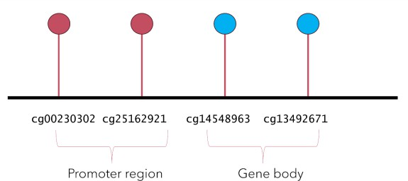
Fi ure 1 B

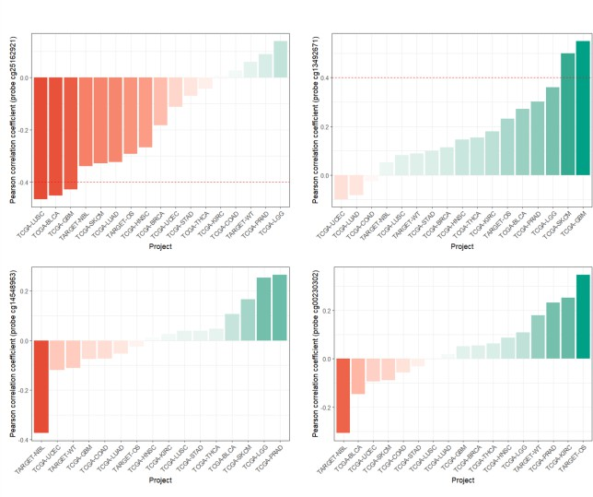
Fi ure 2

Fi ure 3
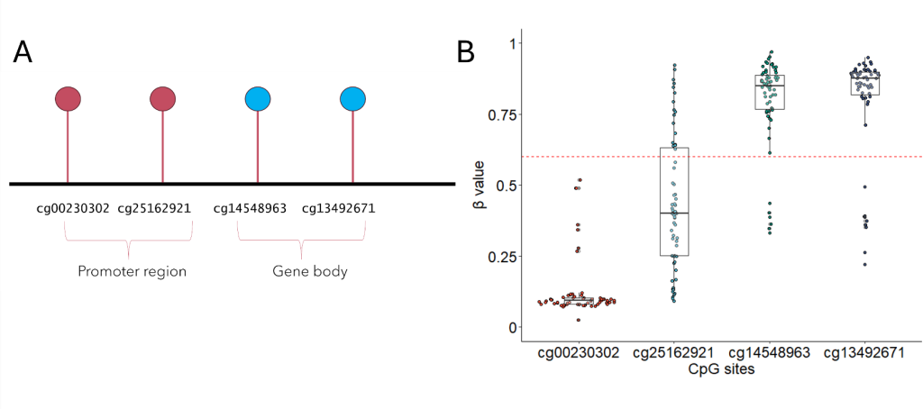

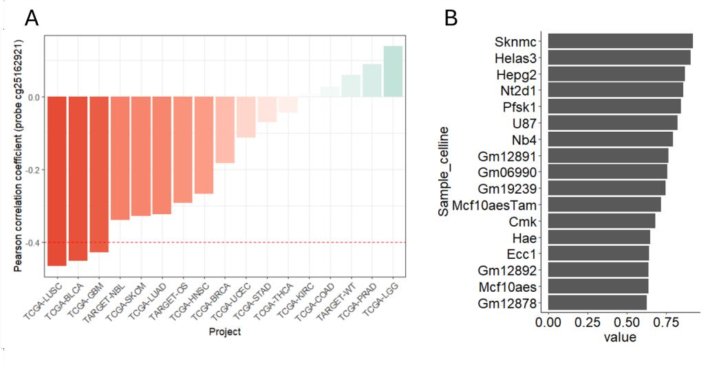
Fi ure 4

